

|  |
| --- |
| [Version 1.0]  **Last saved by: Charlotte Hutchinson**  **Last saved on:** 31/10/2014 |

|  |
| --- |
| Iteration 3 Plan |
| [Publish Date] |
| **Charlotte Hutchinson**  CO600: JustHealth Supervisor: Yang He |

JustHealth Iteration 3 Plan

Table of Contents

1.0 Aims: 2

2.0 Requirements: 2

2.1 Functional requirements: 2

2.2 Non-functional requirements: 2

2.3 Domain Requirements: 3

3.0 Design 3

3.1 Android home screen 3

3.2 Deactivation android 5

3.3 Deactivation web 8

3.4 Database update 9

3.4.1 Conceptual Data Model 10

3.4.2 Logical Data Model 11

3.4.3 Database code 12

3.4.4 Assumptions 14

4.0 Use case: 15

4.1 Login to home screen mobile 15

4.2 Deactivate account mobile and web 15

5.0 Testing restructure 16

# Aims:

* Once a user has logged in on a phone they will be automatically directed to a home screen for either patient or carer.
* To have the ability for a user to be able to de-active their account for both mobile and web.
* When a user de-activates an account they have the option to either erase all their data or for it to be stored on our system in case they wish to return
* When a user selects erase all data, all their data is deleted from the database
* To store reasons why a user wants to de-activate their account
* Re-structure the database
* Re- structure testing

# Requirements:

## 2.1 Functional requirements:

1. Ability to view home page once logged in for carer/ patient- Mobile
2. User has the ability to deactivate their account
3. All data is deleted from their account it they choose this option
4. Data is stored in the database why they want to deactivate their account

## 2.2 Non-functional requirements:

1. User Documentation
2. Robustness
   1. Error handling
3. Ease of Use
   1. Simple and intuitive design
   2. Clear colour scheme

## 2.3 Domain Requirements:

1. Security (Android and web)
   1. Tick box to acknowledge, when they deactivate their account, that their data will be stored on our account if they choose, so they can reactivate their account.
2. Total deletion of all user details from database
3. Modifications to the database to be added to the audit table

# Design

## 3.1 Android home screen

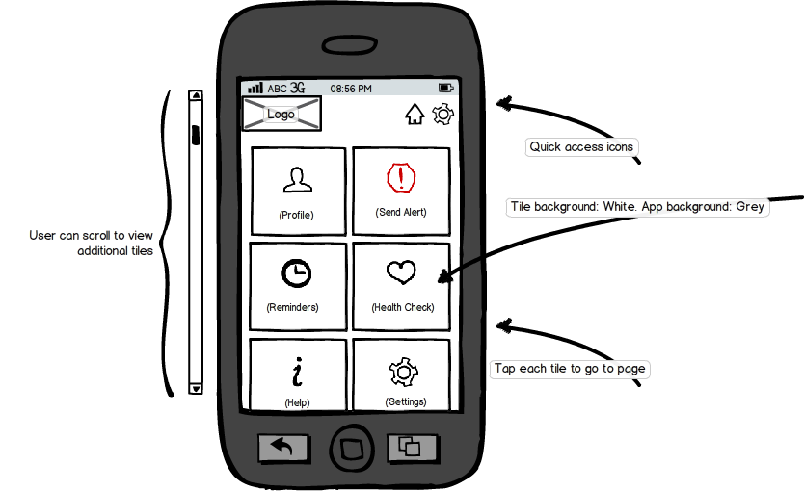

* Tiles will be uniform; prioritised and organised on the page
* Tile icons will be centred and clear to the user
* Once the user has logged in, this will become the redirect location for the ‘Home’ quick access icon
* User will be able to scroll on the screen to view additional icons
* Pressing back here will show the exit screen
* If it is a carer’s account we will have a label stating carer
* All home screens will have the users name

## 3.2 Deactivation android

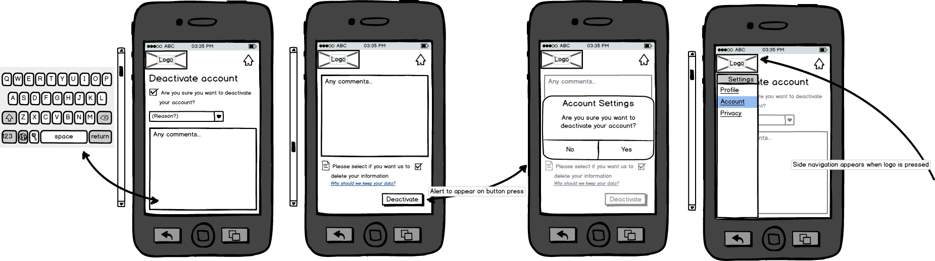

* User will have to fill all fields to proceed
* ‘Reason’ will be a drop down list of the following choices:
  + I don’t understand how to use JustHealth
  + I’m only leaving temporarily
  + I’m using a different app
  + I receive too many notifications and emails
  + I don’t find JustHealth useful
  + I have privacy concerns
  + Other (Please specify)
* Additional comments will be an optional field
* Activating comments field will automatically show native keyboard
* Page will scroll to reveal further required fields, **see** **next design**

## 

* Users have an option to leave information in the JustHealth database, this is to ease reactivating their account
* Link will show pop up window with reasons for user to leave their data
  + Explain security
  + Explain reactivation process
* When ‘deactivate’ button is pressed, final alert window will be shown to user
* On account deactivation, user will be taken to initial application screen displaying ‘Account deactivation successful'

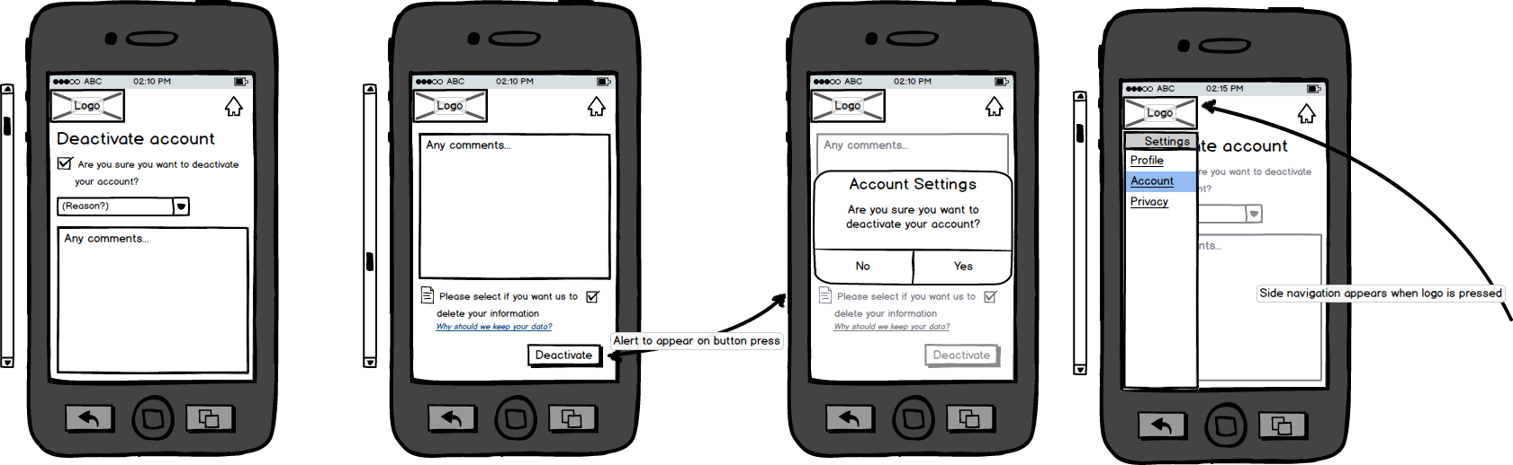

* Pressing the logo will show side navigation bar with a list of settings pages
  + Rest of page will go into disabled state while navigation bar is on show
  + Navigation will show/hide on swipe right/left

## 3.3 Deactivation web

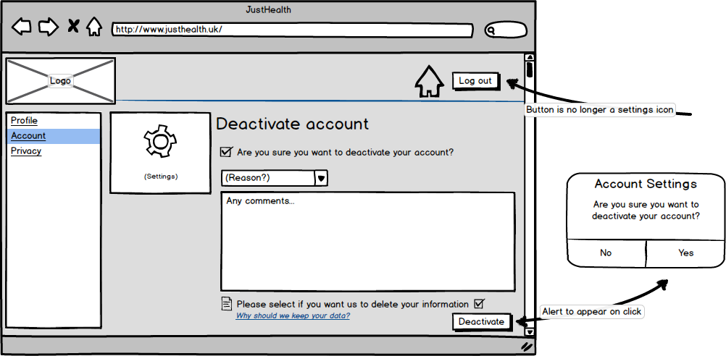

* Idea behind deactivation is to make it simple for the user, but attempt to persuade them otherwise
* All fields (excluding comments) on page will be required
* Options for deactivation reason will be the following:
  + I don’t understand how to use JustHealth
  + I’m only leaving temporarily
  + I’m using a different app
  + I receive too many notifications and emails
  + I don’t find JustHealth useful
  + I have privacy concerns
  + Other (Please specify)
* Additional comments will be an optional field
* Users have an option to leave information in the JustHealth database, this is to ease reactivating their account
* Link will show pop up window with reasons for user to leave their data
  + Explain security
  + Explain reactivation process
* When ‘deactivate’ button is pressed, final alert window will be shown to user
* On account deactivation, user will be taken to initial application screen displaying ‘Account deactivation successful’
* Navigation bar on left side to appear on page load
* Settings icon in header has changed to ‘Log out’ button

## 3.4 Database update

After meeting with Yang and discussing the database we have realised we need to make some changes so it is easier to implement later on and it makes more logical sense. Since we are changing the structure of the database we are doing to re test all of iteration 1 and iteration 2 tests to ensure the database changes have not caused any additional problems. We are also going to test the new database in this iteration. Below are our updated database design, the assumptions and the new database code. For this iteration we are only creating the following tables: Client, Carer, Patient and uq8LnAWi7D (password table). This is because these are the only tables needed for this iteration and since we are following an agile approach we are only implementing what is needed at this stage.

### 3.4.1 Conceptual Data Model

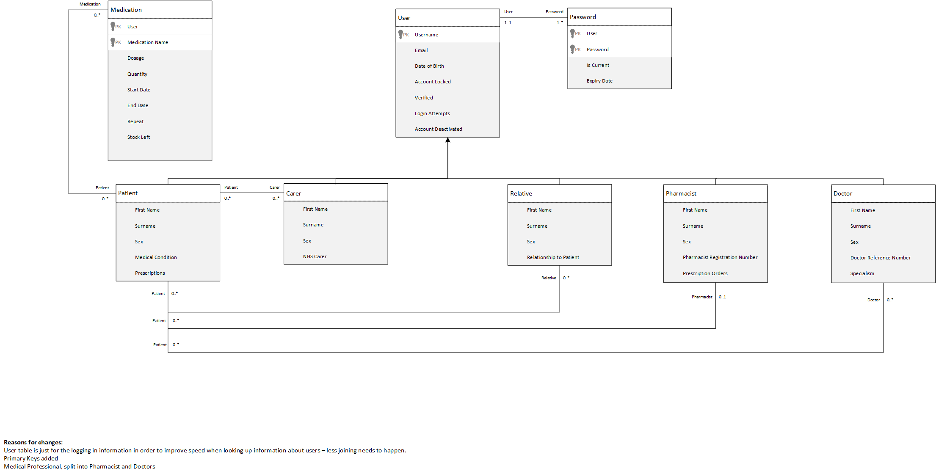

### 3.4.2 Logical Data Model

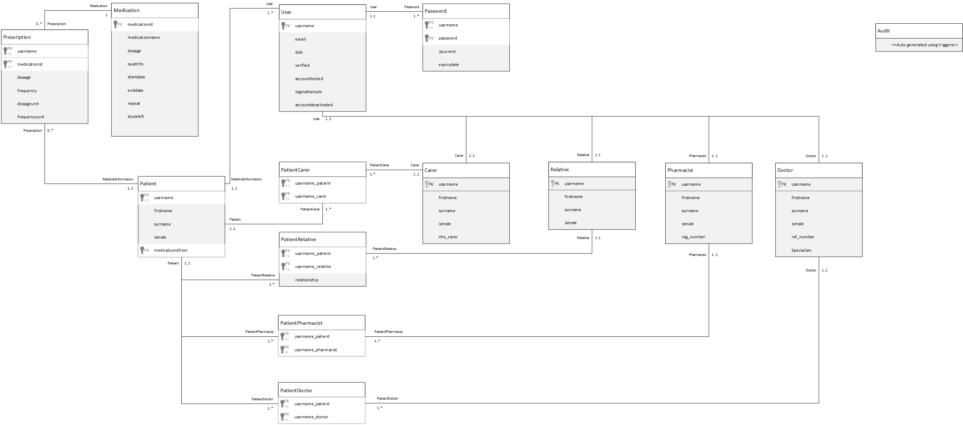

### 3.4.3 Database code

CREATE TABLE Client (

username CHAR(25),

email CHAR(100) NOT NULL UNIQUE,

dob DATE NOT NULL,

verified BOOLEAN NOT NULL DEFAULT FALSE,

accountLocked BOOLEAN NOT NULL DEFAULT FALSE,

loginattempts INTEGER NOT NULL DEFAULT 0,

accountdeactivated BOOLEAN NOT NULL DEFAULT FALSE,

PRIMARY KEY(username)

);

CREATE TABLE Carer (

username CHAR(25) NOT NULL,

firstname CHAR(100) NOT NULL,

surname CHAR(100) NOT NULL,

ismale BOOLEAN NOT NULL,

nhscarer BOOLEAN,

FOREIGN KEY(username) REFERENCES Client(username) ON DELETE CASCADE

);

CREATE TABLE Patient (

username CHAR(25) NOT NULL,

firstname CHAR(100) NOT NULL,

surname CHAR(100) NOT NULL,

ismale BOOLEAN NOT NULL,

FOREIGN KEY(username) REFERENCES Client(username) ON DELETE CASCADE

);

CREATE TABLE uq8LnAWi7D (

username CHAR(25) NOT NULL,

password CHAR(255) NOT NULL,

isCurrent BOOLEAN,

expiryDate DATE,

PRIMARY KEY(username),

PRIMARY KEY(password),

FOREIGN KEY(username) REFERENCES Client(username) ON DELETE CASCADE

);

### 3.4.4 Assumptions

* A patient may not have any medication
* A patient may have more the one medication
* A patient may not have a carer
* A patient can have more then one carer
* A carer can have more then one patient
* A patient may not have a relative
* A patient can have more the one relative
* A relative may have more then one patient
* A patient may not have a pharmacist
* A patient can only have one pharmacist
* A pharmacist may have more then one patient
* A patient may not have a doctor
* A patient can have more then one doctor
* A Doctor can have more then one patient
* A user have to have one password
* A user can have more then one password stored

# 4.0 Use case:

## 4.1 Login to home screen mobile

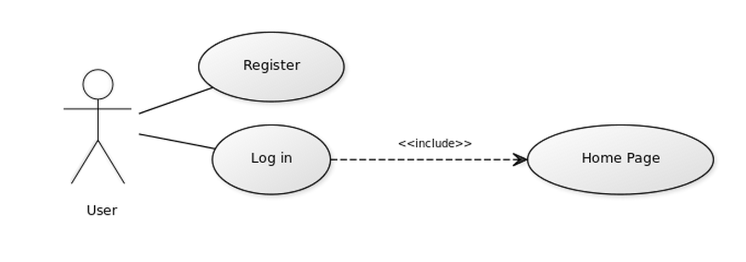

## 4.2 Deactivate account mobile and web

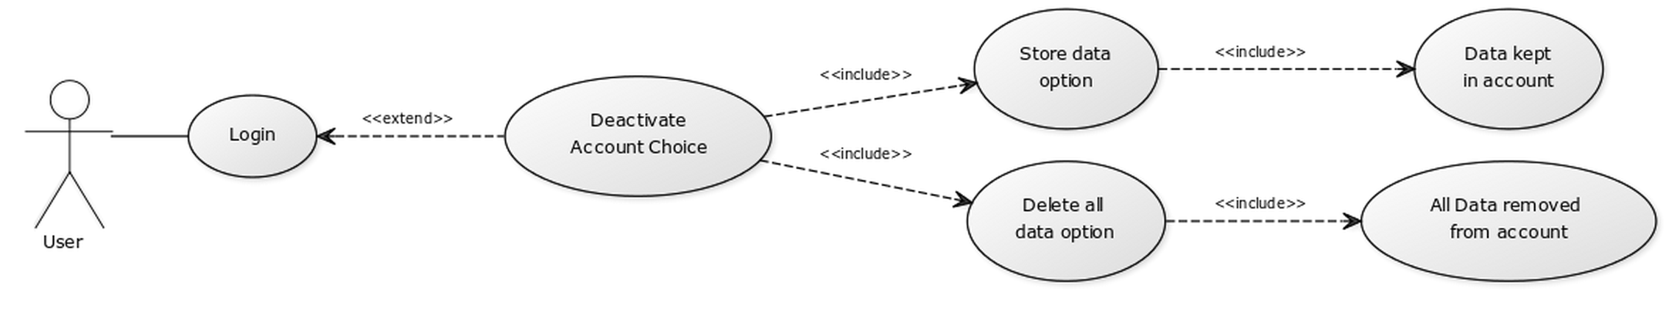

# 5.0 Testing restructure

Due to having significant problems creating and completing the test cases and testing respectively we have come to a decision to change the way we do this. Microsoft Word was causing formatting problems and it was not easy to update or change the test cases. Therefore, as a group we have decided to use a web interface with a back end database.